

**DOCUMENTS MANAGEMENT**

**APPLICATION**

**Software Requirement Specification**

– Ho Chi Minh, May 2022 –

**Table of Contents**

I. Overview 4

1. Introduction 4

2. System Functions 5

a. Screen Flow 5

b. Screen Details 5

c. User Authorization 7

d. Non-Screen Functions 8

3. Common Requirements 8

a. Operating Environment 8

b. Design and Implementation Constraint 8

II. Functional Requirements 9

1. Authentication 9

a. Login 9

b. Registration 9

c. Forgot Password 9

2. System Handler 10

a. Email Sending 10

3. Project Management 10

a. Create new project 10

b. View project list 11

c. Update project 12

d. Project details 12

e. Share documents to project: 12

f. Add members to project 13

g. Disable members in project 13

4. Account Management 13

a. View accounts list 13

b. View user profile 13

c. Search accounts 13

d. Update account 13

e. Create administrator 13

f. Send feedback 14

g. Disable account 14

5. Folder Management 14

a. Create folder 14

b. Upload folder 14

c. Rename folder 14

d. Restore folder 14

e. Remove folder 14

f. Share folder 15

6. File Management 15

a. View delete history 15

b. View files list 15

c. Search file 15

d. View file metadata 15

e. Preview file (docx, xls, pdf) 15

f. Rename file 15

g. Share file 16

h. Upload file 16

i. Remove file 16

j. Restore file 16

k. Sort files list 16

l. Move file 16

m. Add to Starred 16

n. View recent files 17

o. Report file 17

p. Copy file 17

q. Shared with me 17

r. Set file’s permissions 17

s. Download file 17

# Overview

## Introduction

Document management system is designed to organize projects, business files and records digitally, whether they started out in paper form or were generated by software applications. Paper files are first converted to electronic format by scanning. This provides a more compact means of storage, our system will provide for each role lots of way to interact. For example, a guest will be able to view the public file, if you are a registered user, you will have tons of ways to play around with our system, for example you can view, create or upload, delete or update a folder, you can also do the same with files. And there is an admin who can manage all the account in the system.

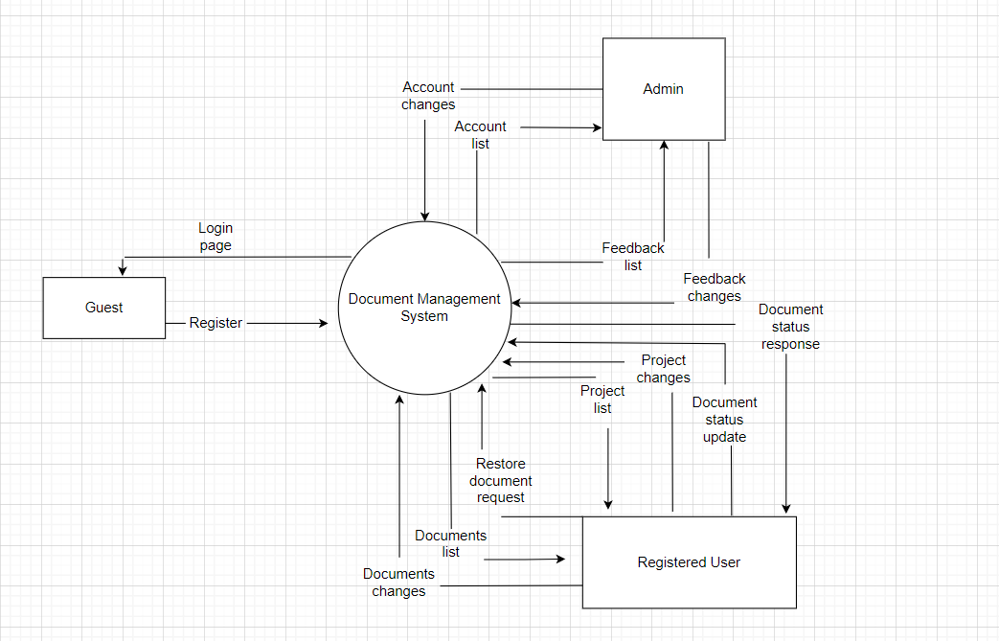

## System Functions

### Screen Flow

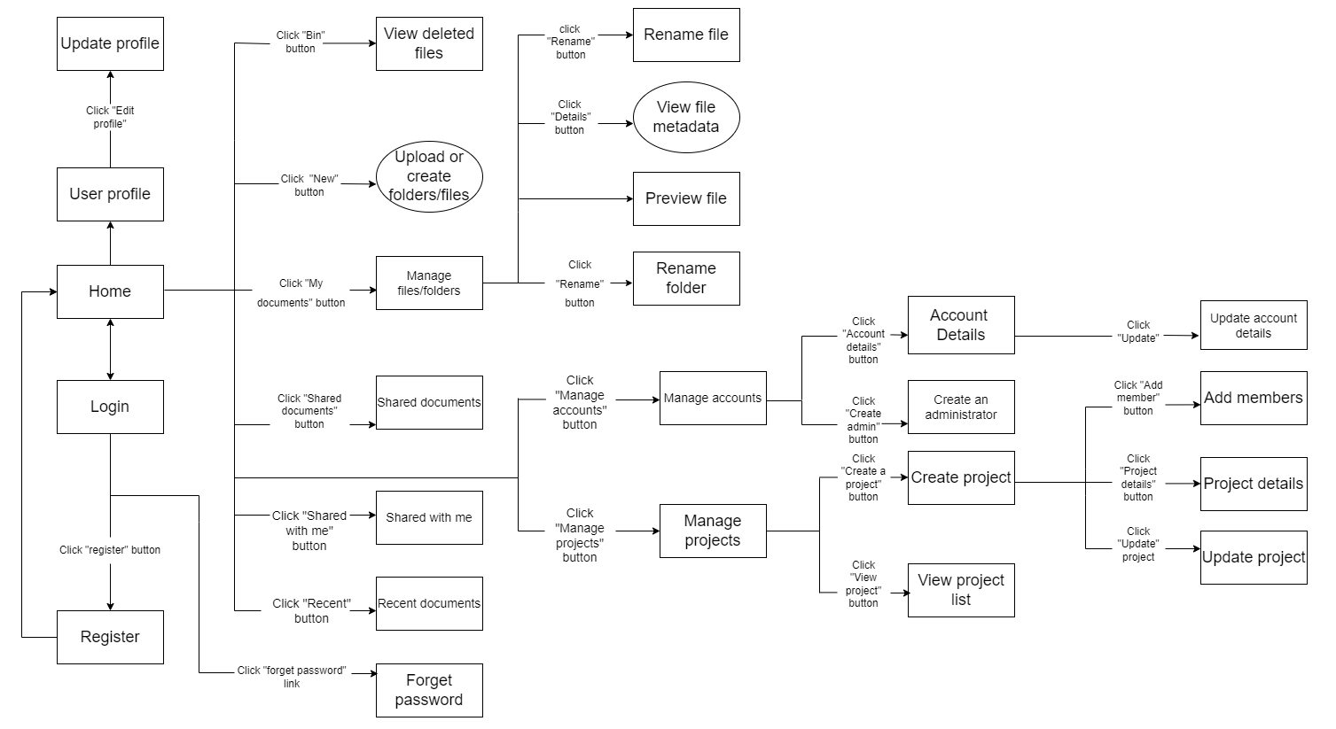

### Screen Details

|  |  |  |  |
| --- | --- | --- | --- |
| **#** | **Feature** | **Screen** | **Description** |
| 1 | Authentication | Home | Show documents, options for each role |
| 2 | Authentication | Login | Allow users to type in their username, password |
| 3 | Authentication | Register | Create new users |
| 4 | Authentication | Forget password | Allow users to recover their password |
| 5 | Authentication | reCapcha | Check reCapcha |
| 6 | Authentication | Login with Google account | Allow users to log in with their Google account |
| 7 | Account management | View user profile | Show all users’ information |
| 8 | Account management | Update profile | Allow users to change their profile |
| 9 | Account management | View account list | Show all the accounts have been registered |
| 10 | Account management | Search accounts | Allow administrator to search for a specific account |
| 11 | Account management | Account details | Show admin the details of selected account |
| 12 | Account management | Create administrator | Allow admin to create an account |
| 13 | Account management | Assign Administrator | Allow admin to assign his/her role to a user |
| 14 | Account management | Update account details | Allow admin to update the information of selected account |
| 15 | Account management | Assign Administrator role | Assign a user to become an administrator |
| 16 | File management | View delete history | Show the files has been deleted |
| 17 | File management | File list with paging | Show list of file |
| 18 | File management | Search file | Allow users to search the file by specific information |
| 19 | File management | View file metadata | Show the details of the selected file |
| 20 | File management | Preview file | Show a preview content of that selected file |
| 21 | File management | Rename file | Allow users to change the file’s name |
| 22 | File management | Share file | Allow users to share their file to others |
| 23 | File management | Upload file | Allow users to upload their files |
| 24 | File management | Delete file | Allow users to delete their files |
| 25 | File management | Restore file | Allow users to restore their file |
| 26 | File management | Sort list file | Allow users to sort the file list |
| 27 | File management | Move file | Allow users to move their file |
| 28 | File management | Add to Starred | Allow users to add a file to starred section |
| 29 | File management | View recent files | Allow users to view their recent files |
| 30 | File management | Filter | Allow users to filter their file |
| 31 | File management | Report a file | Allow users to report a file |
| 32 | File management | Copy file | Allow users to copy a file |
| 33 | File management | Download file | Allow users to download a file |
| 34 | File management | Shared with me | Allow users to know which files are shared with them |
| 35 | File management | Set file permissions | Allow users to set their files’ permissions |
| 36 | File management | Set file’s status | Allow users to change from private to public |
| 37 | Folder management | Create a new folder | Allow users to create a new folder |
| 38 | Folder management | Delete folder | Allow users to delete their folder |
| 39 | Folder management | Rename folder | Allow users to rename their folder |
| 40 | Folder management | Restore folder | Allow users to restore their folder |
| 41 | Folder management | Upload folder | Allow users to upload their folder |
| 42 | Project management | Create a new project | Allow admin to create a new project |
| 43 | Project management | Add members to project | Allow admin to add members to project |
| 44 | Project management | Delete members in project | Allow admin to delete members in project |
| 45 | Project management | View project list | Allow admin to view project list |
| 46 | Project management | Update project | Allow admin to update project |
| 47 | Project management | View project details | Allow admin to view project details |

### User Authorization

|  |  |  |  |
| --- | --- | --- | --- |
| **Screen** | **Role1** | **Role2** | **Role3** |
| 1. Home | X | X | X |
| 1.1 Manage documents | X | X |  |
| 1.2 Delete history | X |  |  |
| 1.3 Log out | X |  | X |
| 1.4 Upload file | X |  |  |
| 1.5 Search | X |  |  |
| 1.6 Shared files | X |  |  |
| 1.7 Manage accounts |  |  | X |
| 1.8 Manage projects |  |  | X |
| 1.9 User profile | X |  |  |
| 1.10 View recent files | X |  |  |
| 1.11 Shared with me | X |  |  |
| 1.12 Filter | X |  |  |
| 1. Manage files | X | X |  |
| 2.1 View file metadata | X |  |  |
| 2.2 Preview a file | X |  |  |
| 2.3 Share file | X |  |  |
| 2.4 Delete file | X |  |  |
| 2.6 Rename file | X |  |  |
| 2.7 Download file | X |  |  |
| 2.8 Sort list file | X |  |  |
| 2.9 Move file | X |  |  |
| 2.10 Add to starred | X |  |  |
| 2.11 Copy file | X |  |  |
| 2.12 Set file’s permission | X |  |  |
| 2.13 Set file’s status | X |  |  |
| 1. Delete history | X |  |  |
| 3.1 Restore file | X |  |  |
| 3.2 Restore folder |  |  |  |
| 1. Manage accounts |  |  | X |
| 4.1 Account details |  |  | X |
| 4.2 Create an administrator |  |  | X |
| 4.3 Search accounts |  |  | X |
| 4.4 Assign Administrator |  |  | X |
| 1. Manage projects |  |  | X |
| 5.1 Create a project |  |  | X |
| 5.2 Add members to project |  |  | X |
| 5.3 Delete members |  |  | X |
| 5.4 View project list |  |  | X |
| 5.5 View project details |  |  | X |
| 5.6 Update project |  |  | X |
| 5.7 Delete project |  |  | X |
| 1. Login | X |  | X |
| 6.1 Register | X |  |  |
| 6.2 Forget password | X |  | X |
| 6.3 reCapcha | X |  | X |
| 6.4 Login with Google account | X |  |  |
| 1. Manage folder | X |  |  |
| * 1. Create a new folder | X |  |  |
| 7.2 Delete folder | X |  |  |
| 7.3 Rename folder | X |  |  |
| 7.4 Upload folder | X |  |  |
| 7.5 Download folder | X |  |  |

In which:

* Role1: Registered user
* Role2: Guest
* Role3: Administrator

### Non-Screen Functions

|  |  |  |  |
| --- | --- | --- | --- |
| **#** | **Feature** | **System Function** | **Description** |
| 1 |  | Send email | When a user share a file to others, a notification email will be sent to them |

## Common Requirements

### Operating Environment

- OE-1: Version 1.0 of the System is designed to operate most effectively on the following web browsers: Internet Explorer 10.0 and 11.0, Mozilla Firefox versions 74 through 88, Google Chrome (all versions).

- OE-2: The DMA will be operating on the stable, commercially approved web server of Apache-tomcat version 8.5.60.

### Design and Implementation Constraint

- CO-1: The coding, maintenance, and implementation shall conform to Java Code Conventions, issued September 12, 1997.

- CO-2: The system shall use mainly Java EE technologies, such as JSP and Servlet.

- CO-3: The system shall use Microsoft’s SQL Server 2019 as the primary database engine.

# Functional Requirements

## Authentication

### Login

* Function trigger: When user click the button “Sign in” on the “login.jsp” page.
* Function description: Roles: Users/Administrators, allow the to sign into the system that they have registered by sending a request consists of a parameter “action” with value “Sign in” to the “MainController” servlet to process.
* Screen layout:

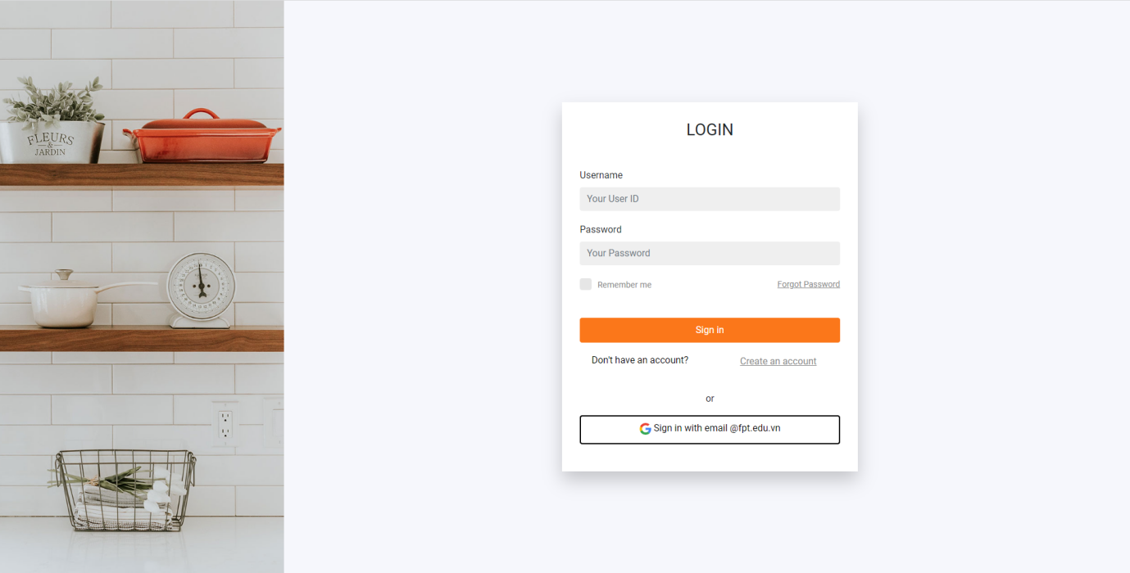

* Function details: In order to sign in, they must register an account, unless they are an administrator. If they sign in with the “User” role, the system will send them to the dashboard page where they can interact with the documents management system. And an administrator will be sent to “Admin” page in which they can manage all the accounts which had been registered in the system. If the user’s ID or password are invalid, an alert will pop up for notification.

### Registration

* Function trigger: When user click the “Create an account” link on the “login.jsp” page, the “registration.jsp” page will show up. After that, click the button “Sign up” to complete your service.
* Function description: Guests are allowed to create a new account, they have to fill in registration form with their personal information. All the information parameters and the “action”, value “Register” will be sent to the “MainController” to handle.
* Function layout:

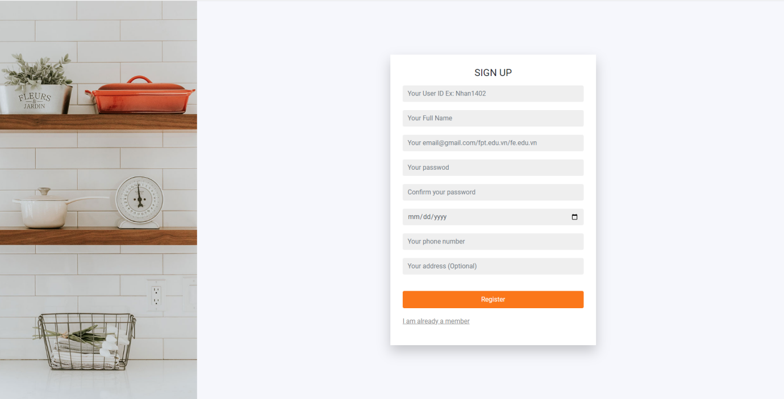

* Function details: In order to sign up, guests have to fill in all their personal information. The system will validate each of the information to make sure they are all appropriate. For example, you can not register an existed user ID and some error messages will be shown on the form. After finishing with no errors, an alert will pop up for notification.

### Forgot Password

* Function trigger: When the users/administrators click the “Forgot your password?” link on the “login.jsp” page. The “forgotPassword.jsp” will show up.
* Function description: Users/Administrators are allowed to retrieve their password. An otp code will be sent to the mail you used to register, after checking the otp, you will need to set a new password, confirm it and click the “Confirm” button.
* Function layout:

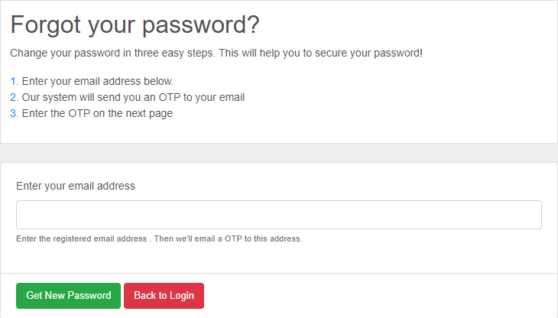

* Function details: In order to retrieve you password, you must have an registered account in system. After checking that your email/userID is existed, the system will send to you an email contains an otp code, if you enter an invalid otp code, an error message will show up. After that, you need to set up and confirm your new password, if they do not match, an error will show up. Finishing all the steps, your new password is ready to go.

## System Handler

### Email Sending

* Function trigger: When you type in the email in order to retrieve your password, or when you share a document to someone else, an email will be sent to them for notification.
* Function description: It is a non-screen function, it will be automatically handled by our system
* Function details: You have to add some of the java Mail libraries so as to implement it, after that you have to define all the classes and methods. When you forgot your password, an otp code will be sent to your mail, or you want to share your document to someone else, an email will be sent to them.

## Project Management

### Create new project

* Function trigger: When user click the button “Project” on the “index.jsp” page. , the “projectlist.jsp” page will show up in the “projectlist.jsp” page click the button “create project” to enter “createProject.jsp”page
* Function description: Users are allowed to create a new project, they have to fill in form with their information. All the information parameters and the “action”, value “Create” will be sent to the “CreateProjectController” to handle.
* Function layout:

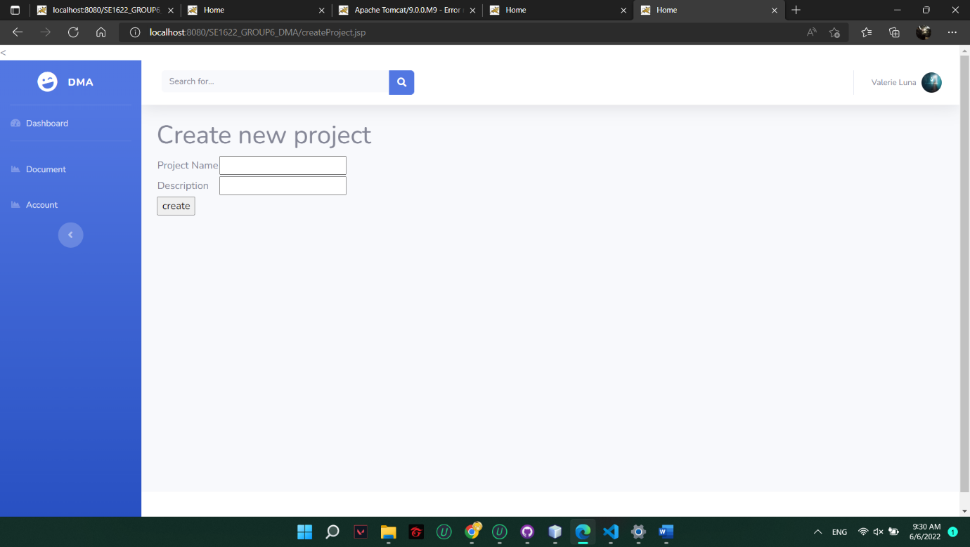

* Function details: In order to create project, users have to fill in all their information. The system will validate each of the information to make sure they are all appropriate.Error messages will be shown on the form when its occur. After finishing with no errors,user will return to the project list.

### View project list

* Function trigger: When user click the button “Project” on the “index.jsp” page. , the “projectlist.jsp” page will show up.
* Function description: Users allow to see all the projects . All the information parameters will be sent to the “ViewProjectController” to handle.
* Funtion layout:

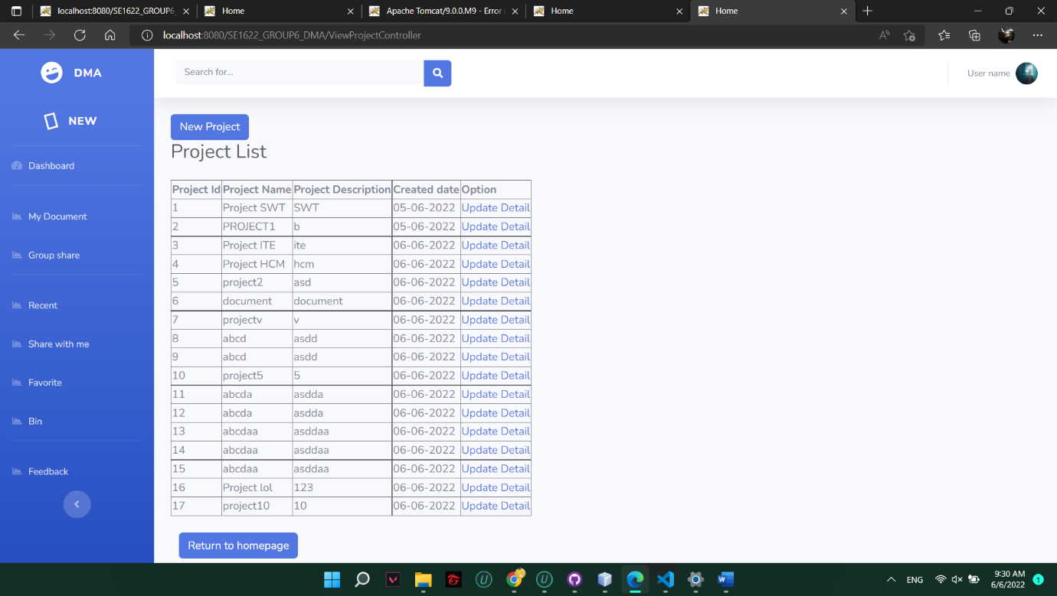

* Function details: In order to view project, users have to create the project first. The system will validate each of the information to make sure they are all appropriate.Error messages will be shown on the form when its occur. After finishing with no errors,user will return to the project list.

### Update project

* Function trigger: When user click the button “Project” on the “index.jsp” page. , the “projectlist.jsp” page will show up in the “projectlist.jsp” page click the button “update”to enter “updateProject.jsp”page
* Function description: Users allow to edit all the projects . All the information parameters will be sent to the “ProjectUpdateController” to handle
* Function layout:

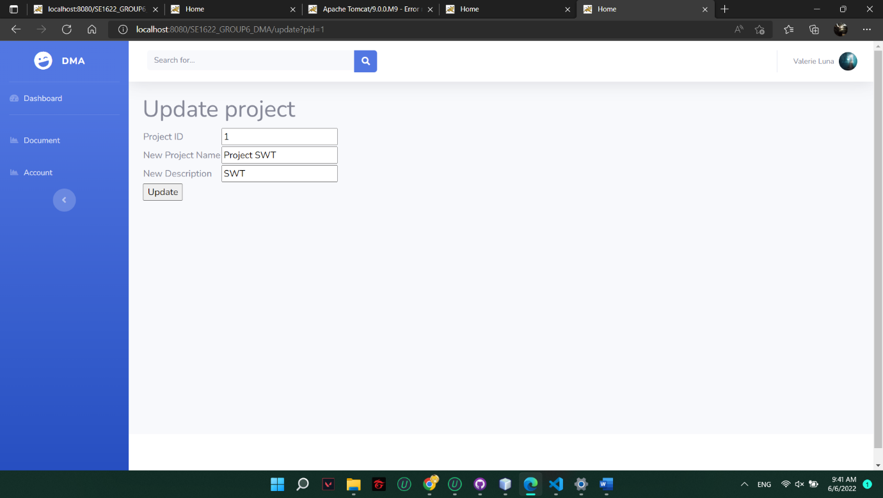

* Function details: In order to update project, users have to create the project first and users have to fill in all their information. The system will validate each of the information to make sure they are all appropriate.Error messages will be shown on the form when its occur. After finishing with no errors,user will return to the project list.

### Project details

* Function trigger: When users click on the button “Details” on the “projects.jsp” page, the details of a project will be shown.
* Function description: When users click the button “Details”, a parameter “action” with value “projectDetails” will be sent to the “MainController” to handle.
* Function layout:

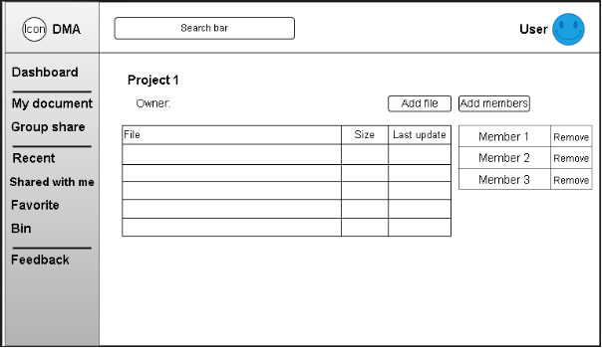

* Function details: In order to view project details, you have to be a member of it. If not, the system will redirect you back to the “index.jsp” page. Otherwise, all the information of that project will be loaded on to the “projectdetails.jsp”. Error messages will be shown on the page when it occurs.

### Share documents to project:

* Function trigger: When users click on the “Add documents” on the “projects.jsp” page. A drop down with three options will be shown for the user to choose.
* Function description: When the users click the “Create folder” option, it will send the parameter “action” with value “createFoler”, on the “Upload folder” the value will change to “uploadFolder” and “Upload file”, it will be “uploadFile”. All of that will be sent to the “MainController” to handle.
* Function layout:

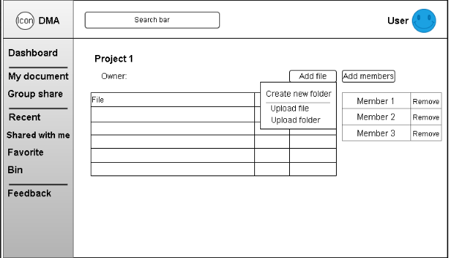

* Function details: It allow a member of that project to share documents to others to view, others that are not member, will be redirected back to the “index.jsp” page. And all the documents’ permissions will be set to “Edit” mode for all members to work on it.

### Add members to project

* Function trigger: When the users click on the button “Add members” on the “projects.jsp” page.
* Function description: When it happens, the parameter “action” with value “addMember” will be sent to the “MainController” to handle.
* Function layout:

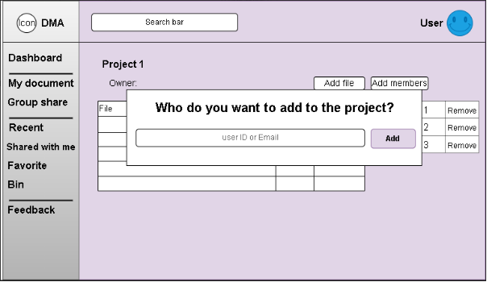

* Function details: Only the manger of that project can add new members, otherwise the button will be invisible, the manager needs to type in the member’s userID or email to proceed.

### Disable members in project

* Function trigger: When the manager click on the button “Remove” in the “projectdetais.jsp” page.
* Function description: It allows the manager to remove any members from the current project. A parameter “action” with value “removeMember” will be sent to the “MainController” to handle.
* Function layout:

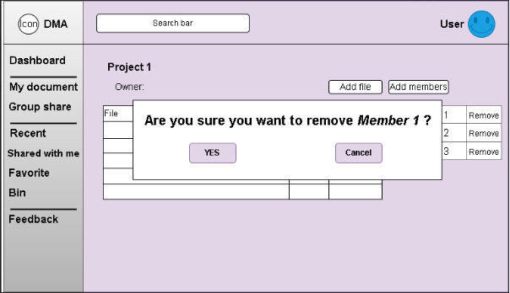

* Function details: Only the manager of that project can remove members, otherwise the button will be invisible, errors will be shown on the page when it occurs.

## Account Management

### View accounts list

* Function trigger: When the administrator click “Accounts” on the side bar.
* Function description: It will show all the accounts that have been registered to our system, a parameter “action” with value “Accounts” will be sent to the “MainController” to handle.
* Function layout:

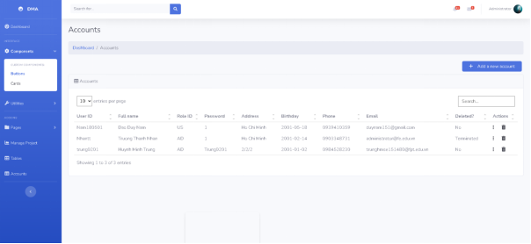

* Function details: It will load all information of all accounts, including the account whose role is “Admin” onto the “accounts.jsp” page. Error will be shown on the page when it occurs.

### View user profile

* Function trigger: When the users click on the button “Profile” on “index.jsp” page.
* Function description: It allow users to see if the information they registered with is correct or not. If not, they can change it. A parameter “action” with value “Profile” will be sent to the “MainController” to handle.
* Function layout:

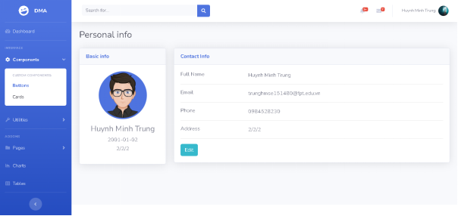

* Function details: It will load the information of a user and show it on the “profile.jsp” page, users will check if the information is accurate and they can continue to update it. Errors will be shown on the page when it occurs.

### Search accounts

* Function trigger: When admin type in the information they want to search in the search bar on the “accounts.jsp” page.
* Function description: It allows admin to search for the the user which contains the parameter value “search”, and it will be sent to the “MainController” to handle.
* Function layout:

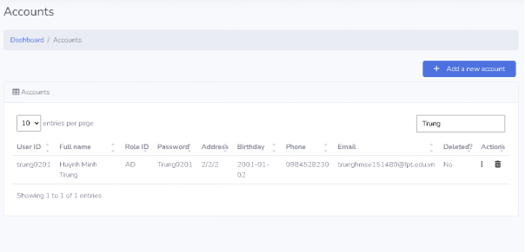

* Function details: Administrator can type in the information of an account they want to search. All the accounts that match the parameter will be shown on the “accounts.jsp” page. Errors will be shown on the page when it occurs.

### Update account

* Function trigger: When users click on the button “Update” on the “profile.jsp” page.
* Function description: It allows user to change their information if it is incorrect. A parameter “action” with value “Update” will be sent to “MainController” to handle.
* Function layout:

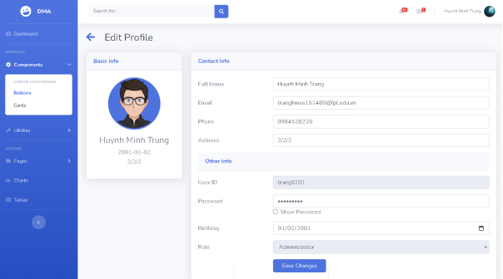

* Function details: All the information the users change will be sent to the “UpdateUserProfileController”, if it meets the validated requirement, the “profile.jsp” will be shown for user to check again. If not, errors will be shown to the incorrect input.

### Create administrator

* Function trigger:
* Function description:
* Function layout:
* Function details:

### Send feedback

* Function trigger: When users click on the button “Feedback” on the “index.jsp” page.
* Function description: It allows users to send feedback they want the app to improve on. A parameter “action” with value “Feedback” will be sent to “MainController” to handle.
* Function layout:
* Function details: The feedback sent will be handled by administrator, when admin click the button “Received”, a notification will be sent to the user who sent it, content and type of feedback will be sent to “FeedbackController” to handle. Errors will be shown when it occurs.

### Disable account

* Function trigger: When admin click on the button “Remove” on the “accounts.jsp” page.
* Function description: It will disable the account that admin decided on, when the user try to log in with it, a alert will show up says “Your account has been disabled. Please contact us for further notice”. A parameter “action” with value “Delete” will be sent to the “MainController” to handle .
* Function layout:

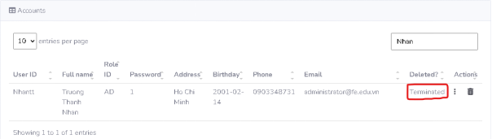

Then:

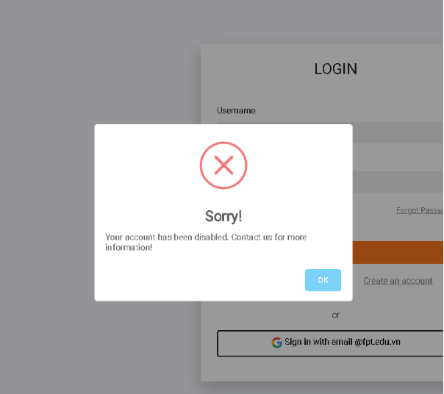

* Function details: It will completely delete the account from the system, we just simply disable if you violate some of our policies, you can always contact the admin to enable it again. All of the requests will be proceeded by the “DeleteAccountController”. Errors will be shown when it occurs.

## Folder Management

### Create folder

* Function trigger: When user click on the button “New”, after that choose the “Create folder” option.
* Function description: It allows user to create a blank folder and will be shown on the “mydocuments.jsp” page. A parameter “action” with value “createFolder” will be sent to the “MainController” to handle.
* Function layout:

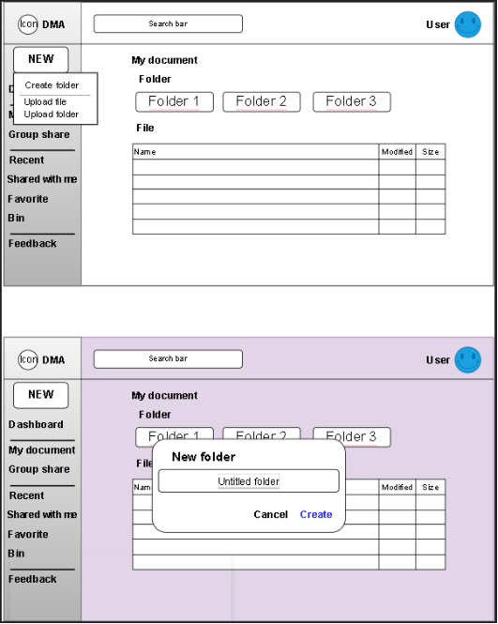

* Function details: When clicked, a pop-up will show up for user to give that folder a specific name and with validation. All of the requests will be proceeded by the “CreateFolderController”. Errors will be shown on the page when it occurs.

### Upload folder

* Function trigger: When user click on the button “New”, after that choose the “Upload folder” option.
* Function description: It allows user to a folder from their computer and will be shown on the “mydocuments.jsp” page. A parameter “action” with value “uploadFolder” will be sent to the “MainController” to handle.
* Function layout:

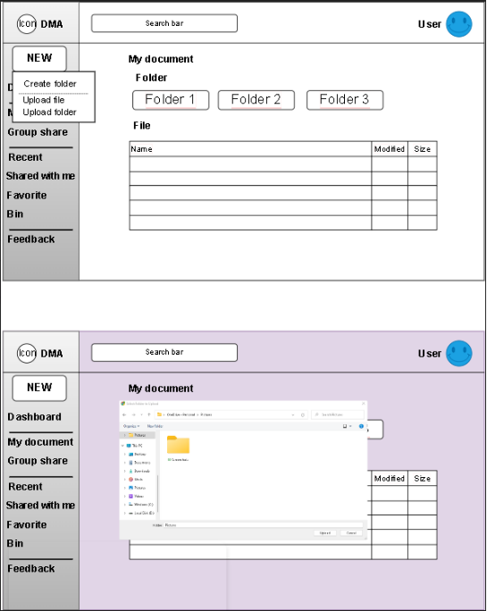

* Function details: When clicked, a pop-up will show up for user to the folder they want to upload. All of the requests will be proceeded by the “UploadFolderController”. Errors will be shown on the page when it occurs.

### Rename folder

* Function trigger: When the user right-clicks on a specific folder, a drop-down menu with option “Rename” will show up.
* Function description: It allows user to rename the folder which has been uploaded or created. A parameter “action” with value “Rename” will be sent to the “MainController” to handle.
* Function layout:

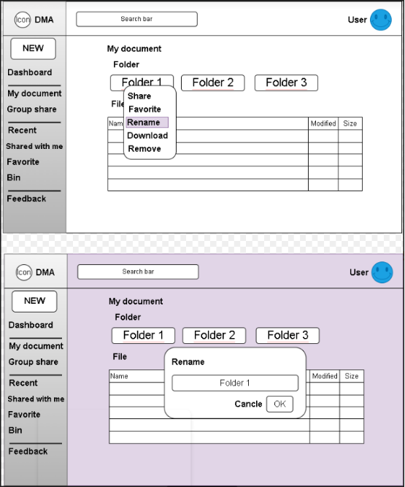

* Function details: When the user want to rename a folder, there are some validations they have to follow, ex : naming folder convention, .. If not, errors will be shown on the page when it occurs.

### Restore folder

* Function trigger: When the user go the “bin.jsp” page, and click on the button “Restore” of a specific folder.
* Function description: It allows user to restore their removed folders in required days. A parameter “action” with value “Restore” will be sent to the “MainController” to handle.
* Function layout:

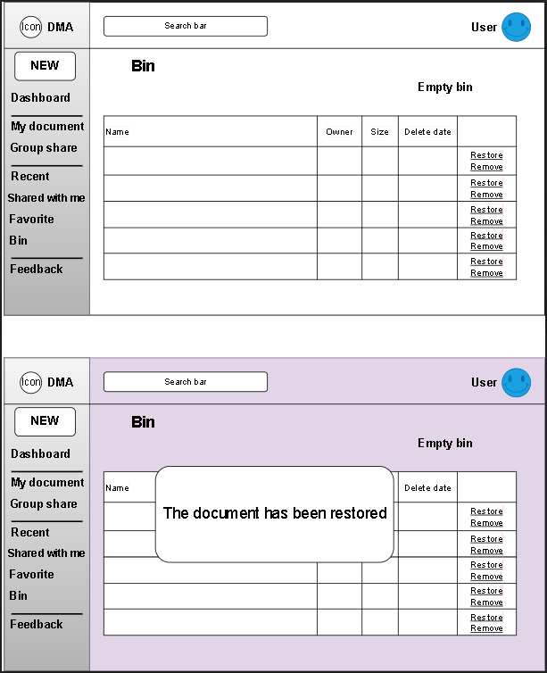

* Function details: The “MainController” will forward to the “”RestoreDocumentsController” to handle. If restores successfully, the “mydocuments.jsp” will be shown to notify the user. If not, errors will be shown on the page when it occurs.

### Remove folder

* Function trigger: When the user right-clicks on a specific folder, a drop-down menu with option “Remove” will show up.
* Function description: It allows user to remove the folder which has been uploaded or created. A parameter “action” with value “Remove” will be sent to the “MainController” to handle.
* Function layout:

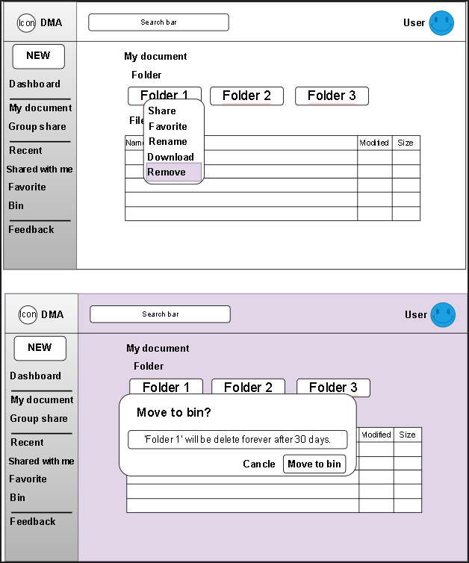

* Function details: If some specific folders that users do not want to store anymore, just hit the “Remove” button. All the removed ones will not be completely removed, they will be sent to “bin.jsp” page if the users want to restore. All the requests will be proceeded by the “RemoveDocumentController”, errors will be shown on the page when it occurs.

### Share folder

* Function trigger: When the user right-clicks on a specific folder, a drop-down menu with option “Share” will show up. After that, that user just need to copy the link provided by the system in order to share it.
* Function description: It allows the user to share their folder for others to work with, a parameter “action” with value “shareFolder” will be sent to the “MainController” to handle.
* Function layout:

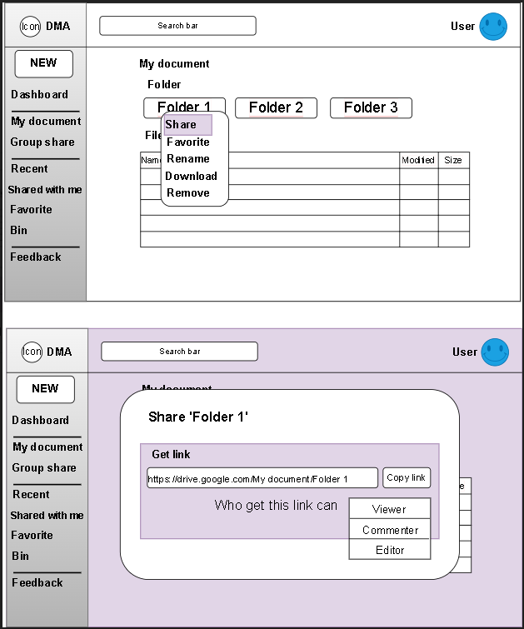

* Function details: When clicked, it will generate a link and set permission for anyone who has the link can impact that specific folder. All the requests will be proceeded by the “ShareDocumentController”, errors will be shown on the page when it occurs.

## File Management

### View delete history

* Function trigger: When the user click on the button “Bin” on the “index.jsp” page.
* Function description: It allows user to know all the documents they have removed in the last x days. A parameter “action” with value “viewBin” will be sent to the “MainController” to handled.
* Function layout:

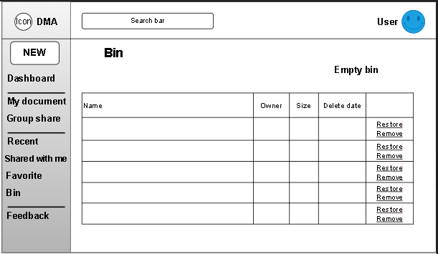

* Function details: This function will show all the documents on the “bin.jsp” to the users, all the parameters will be proceeded by the “”ViewHisoryController”. Errors will be shown on the page when it occurs.

### View files list

* Function trigger: When the user click on the button “My Documents” on the “index.jsp” page.
* Function description: It allows user to view all the documents they have uploaded or created to the system. A parameter “action” with value “View” will be sent to “MainController” to handle.
* Function layout:

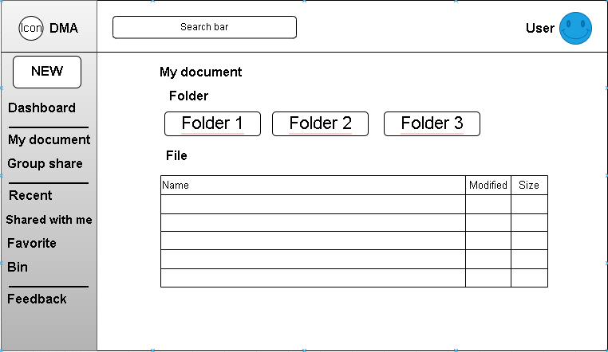

* Function details: This function will show all the documents on the “mydocuments.jsp” page and let user continue their work. All the parameters will be proceeded by the “ViewDocumentsController”. Errors will be shown on the page when it occurs.

### Search file

* Function trigger: When the user fill in the document’s name on the search bar on the “index.jsp” page.
* Function description: It allows user to search for their wished document by inputting the document’s name. A parameter “action” with value “searchDocument” will be sent to the “MainController”, errors will be shown on the page when they occur.
* Function layout:

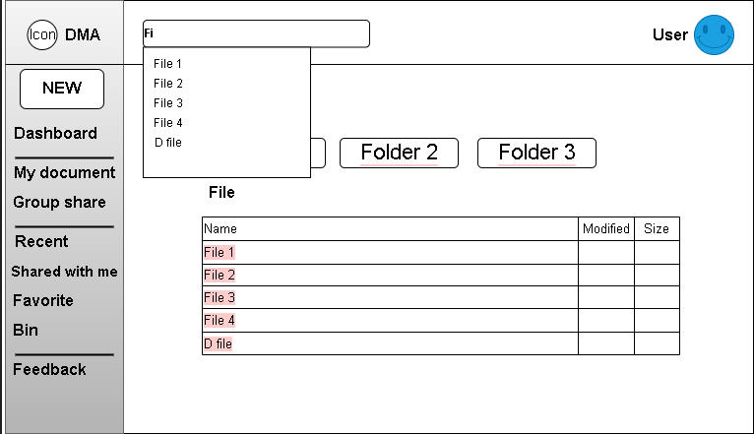

* Function details: This function shows all the document which match the inputted name from the user, if documents existed, the “index.jsp” page will be reloaded with all of them attached. All the parameters will be proceeded by the “SearchDocumentsController”

### Preview file (docx, xls, pdf)

* Function trigger: When user click the button Preview file.
* Function description: It allows user to preview a file.
* Function layout:
* Function details: This function help user preview exactly file that user want to preview.

### Rename file

* Function trigger: When user click the button Rename file.
* Function description: It allows user to rename a file.
* Function layout:
* Function details: This function help user rename exactly file that user want to rename.

### Share file

* Function trigger: When user click the button Share file.
* Function description: It allows user to share a file.
* Function layout:
* Function details: This function help user get a link of an exactly file that user want to share.

### Upload file

* Function trigger: Click dropdown button “New”, choose “Upload File”.
* Function description: It allows user to upload a file.
* Function layout:
* Function details: This function help user to upload a file.

### Remove file

* Function trigger: When user click the button Remove file.
* Function description: It allows user to remove a file to bin.
* Function layout:
* Function details: This function help user to remove a file to bin.

### Restore file

* Function trigger: When the user click on the button “Bin”
* Function description: It allows user to restore a file from bin.
* Function layout:
* Function details: This function help user to restore a file from bin.

### Add to Starred

* Function trigger: Hover over the file, choose “Add to star”.
* Function description: It allow user to star a file.
* Function layout:
* Function details: This function help user to star a file.

### View recent files

* Function trigger: When user click button “Recent” in sidebar.
* Function description: It allow user to view recent file open.
* Function layout:
* Function details: It allow user to view recent file open.

### Report file

* Function trigger: When user hovers over the file, choose “Report file”.
* Function description: It allow user to report a file.
* Function layout:
* Function details: It allow user to report a file.

### Copy file

* Function trigger: When user hovers over the file, choose “Copy file”.
* Function description: It allow user to copy a file.
* Function layout:
* Function details: It allow user to copy a file.

### Shared with me

* Function trigger: When user click button “Share with me” in sidebar.
* Function description: It allow user to view shared file.
* Function layout:
* Function details: It allow user to view shared file.

### Download file

* Function trigger: When user hovers over the file, choose “Download file”.
* Function description: It allow user to download a file.
* Function layout:
* Function details: It allow user to download a file.